



Computational Geometry
LAB MANUAL

Disclaimer: The content is curated from online/offline resources and used for educational purpose only
Write a function to detect if two line segments intersect. Test the algorithm with edge cases (collinear, overlapping).

Objective:
Write a function to detect whether two line segments intersect and test the algorithm against various edge cases such as collinear and overlapping segments.
Problem Statement:
Given two line segments, each defined by two endpoints, determine whether the segments intersect. The solution must handle edge cases such as overlapping and collinear segments.

Equipment Required:
- Python installed with Jupyter Notebook

Prerequisites:
- Understanding of basic geometry concepts
- Familiarity with programming conditional logic

Procedure:
Step 1: Define Orientation and On-Segment Functions
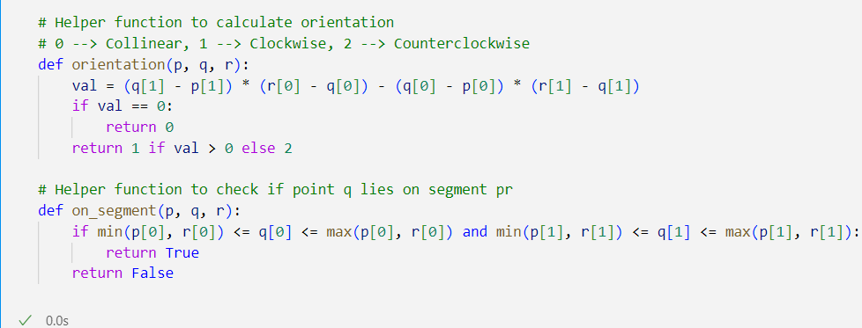

Step 2: Define the Segment Intersection Function

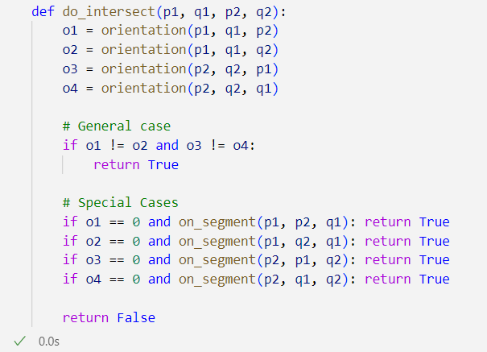

Step 3: Test the Function with Edge Cases
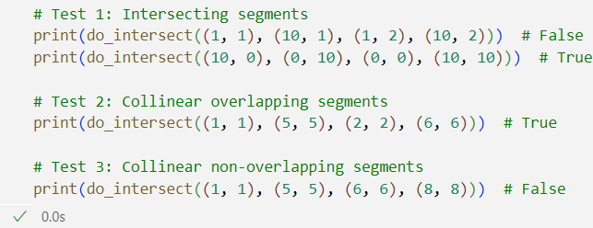

Output:
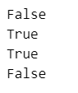

Conclusion
This lab demonstrated how to detect intersection between two line segments using orientation and bounding box checks. The method efficiently handles general intersections and special edge cases such as collinearity and overlap. Such geometric algorithms are foundational in computational geometry applications like computer graphics, robotics, and GIS systems.

